Operating guideline

First, for the Single Step mode, you need to click the IPL button to stop the machine at the beginning and ready for the user to hit run or single step.

You can store the value into X1 to X3 and R0 to R3 registers in binary (just click the plot and push store button) or the default setting is 0.



And then input the memory value corresponding to the address, you can also load the address to check the value by load button.

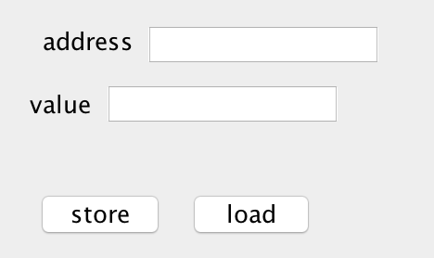

All the commands you made will be shown in the console.

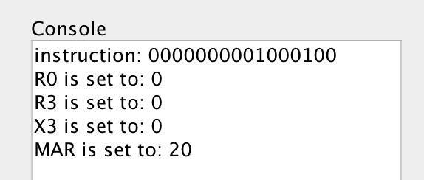

You can input the instruction in binary.



and push execute button.



Then MAR, MBR and other results will be shown in the blank.

For the IPL mode, you don’t need to do anything. The memory will load from pre-set ROM.